

# Introduction

## EMAIL BOT –UI PATH

* An email bot is an automated marketing tool that can respond quickly to incoming email leads. This BOT can automate the old hat tasks. This bot can read data from excel file, extract email id and send personalized mails to recipient and lot more.
* One can send personalised emails to the recipients and bot can take input from excel file.

# User Interface

Welcome to users interface. In this section, we will cover the basic and advanced operations of the bot available to the users.

Bot is compatible with all the major windows operating systems including:

* Windows 7
* Windows 8.1
* Windows 10
* (all variants 32bit and 64bit)
* ***\*Your computer should have .net framework in order to install/run Bot (generally it comes with windows else you have to download it from Microsoft).***

***\*It is always recommended to keep your windows updated to the latest build. Once you have completed the above pre-requisites you can below screenshots.***

***\*Open google and search of ui path click on the link just as shown in screenshot below.↓***

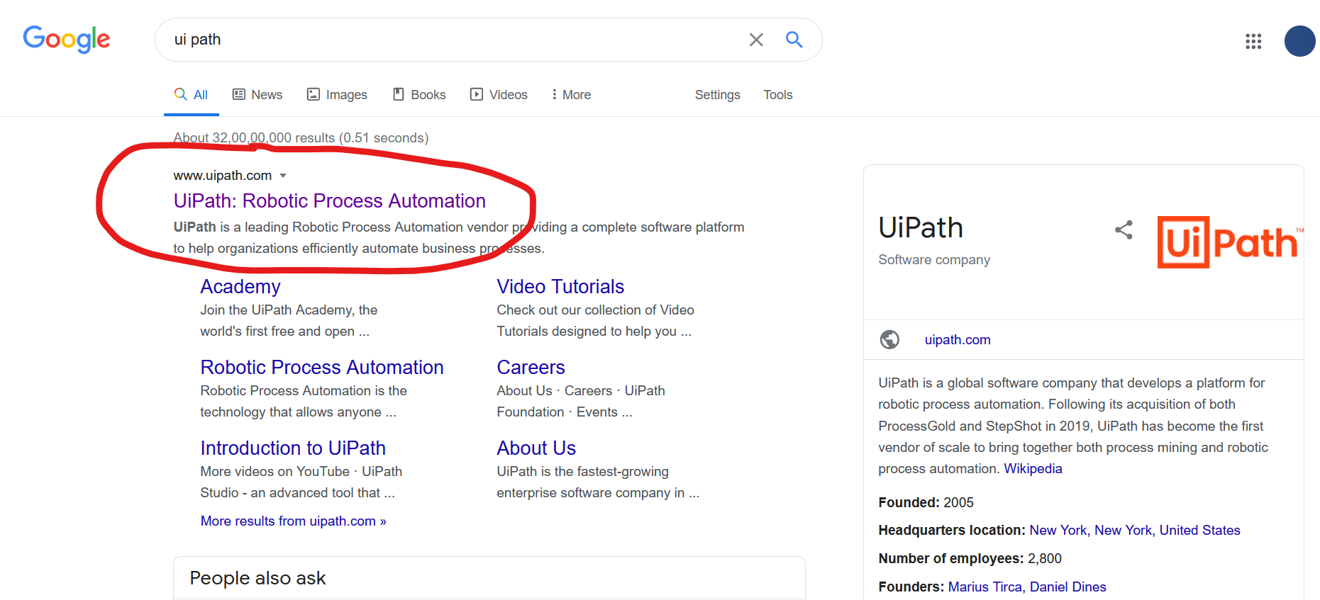

***\*After opening the site of ui path click on Try UI Path Free***



***\*Create a account for UI Path using the methods given on site***

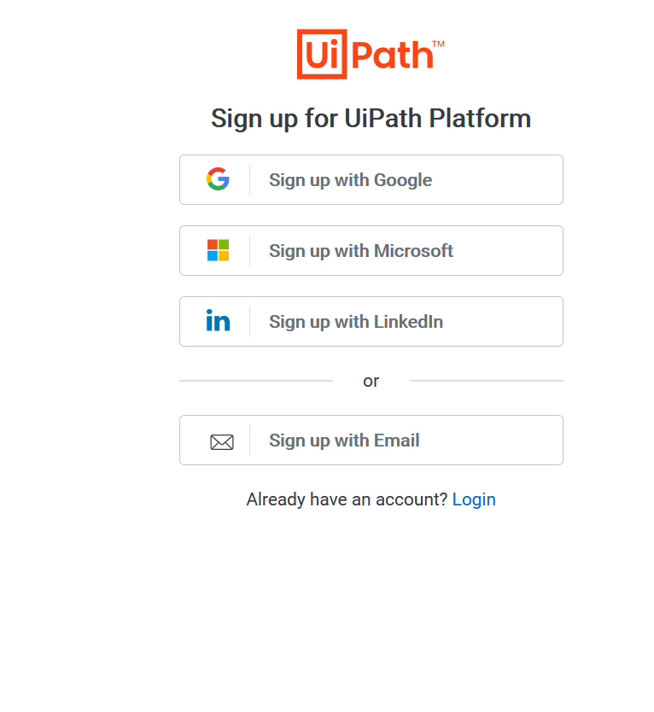

***\*After registration a page like the below will open. Click on Download Studio/StudioX***

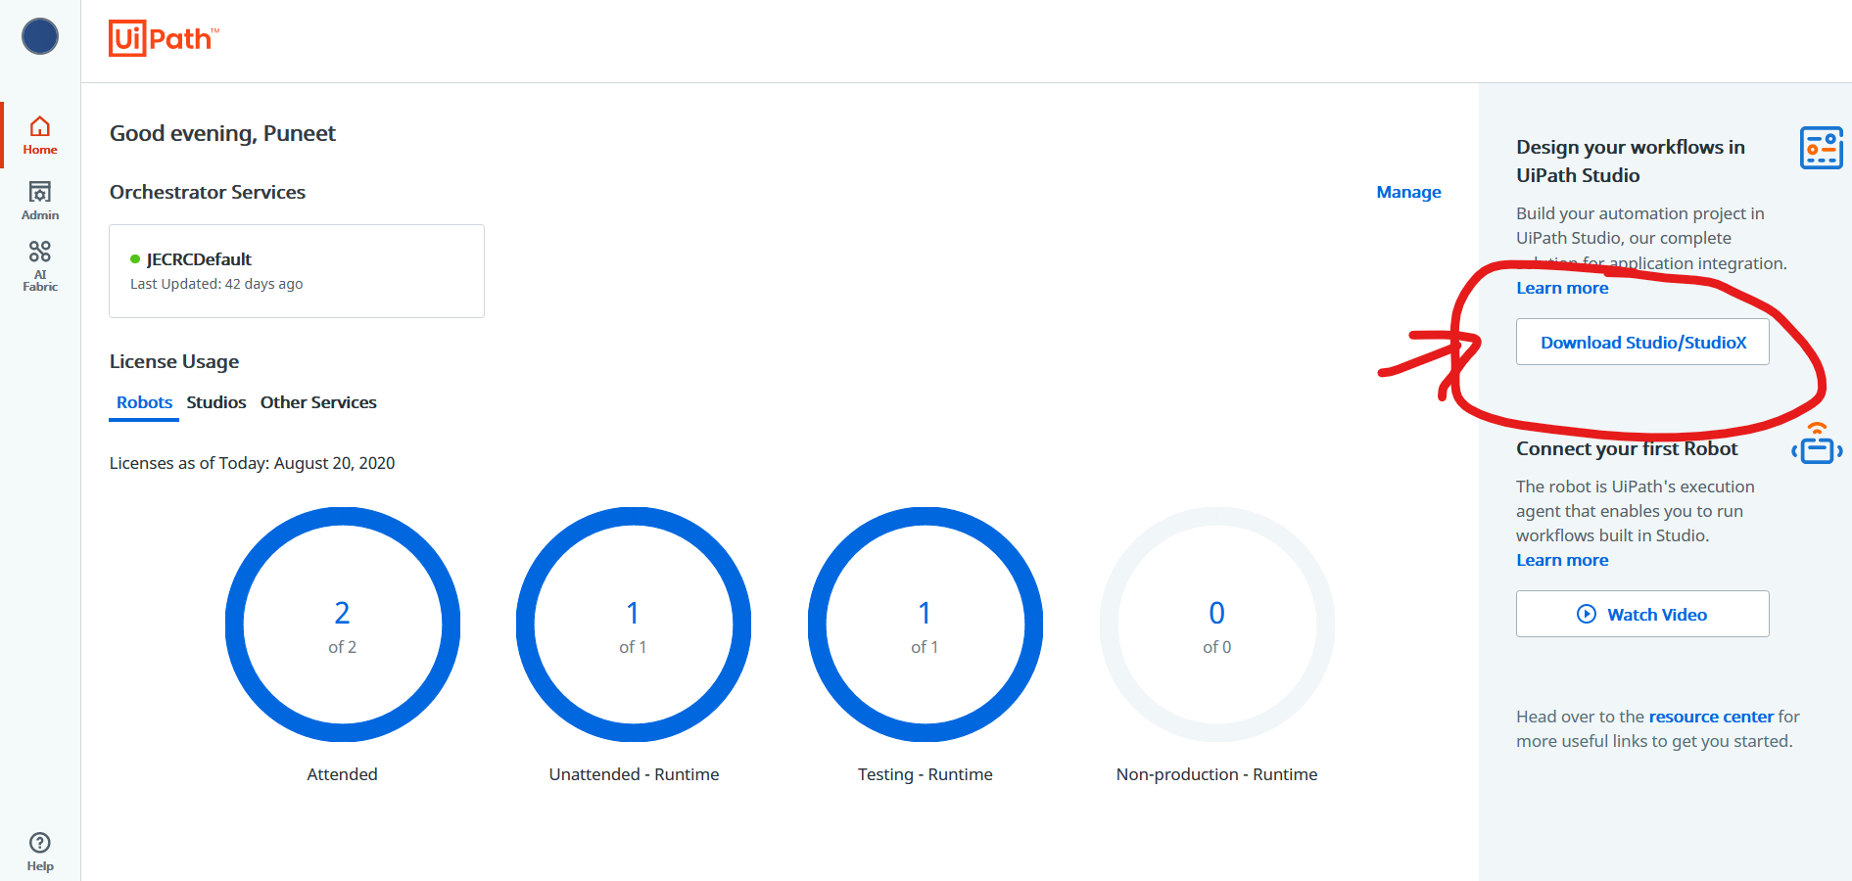

***\*Download this file and open .***

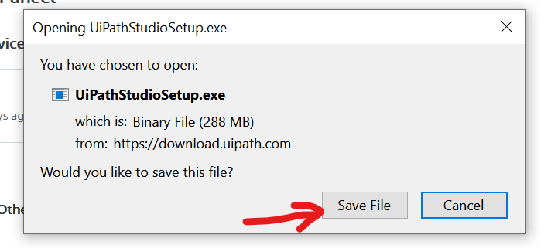

***\*Let it be install for some time after some time a window like this will open follow the below steps.***

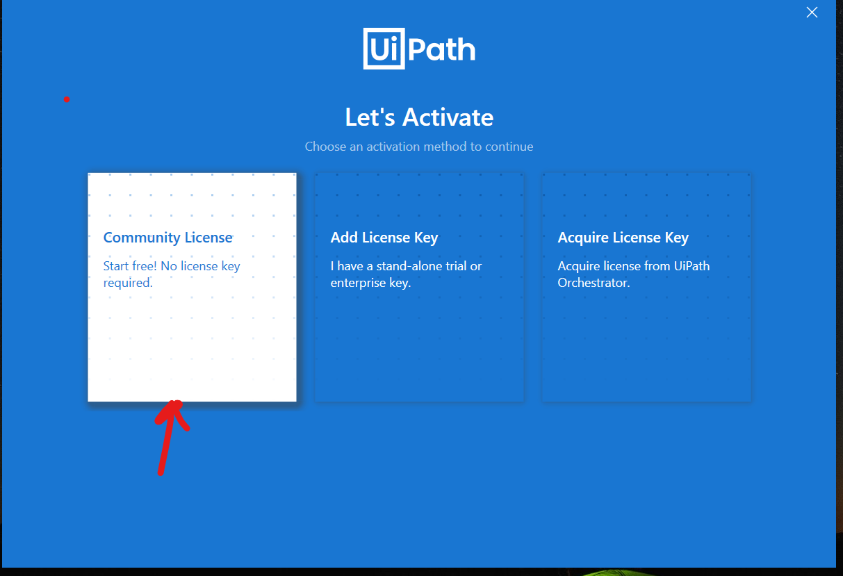

**\*Click on Community License**

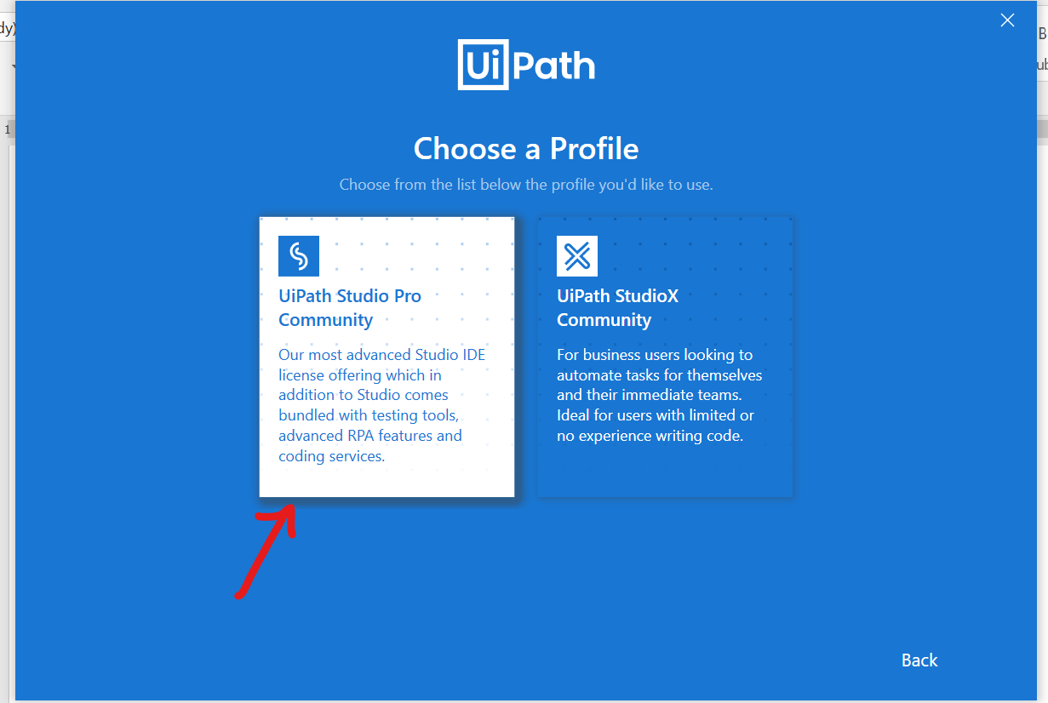

**\*Click on UiPath Studio Pro Community.**

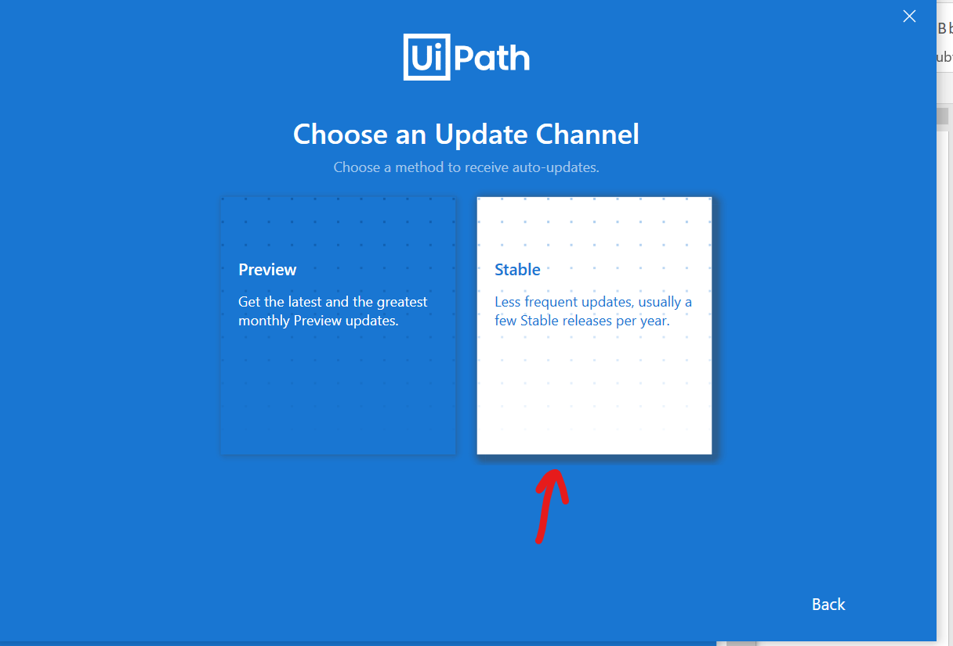

**\*Click on Stable.**

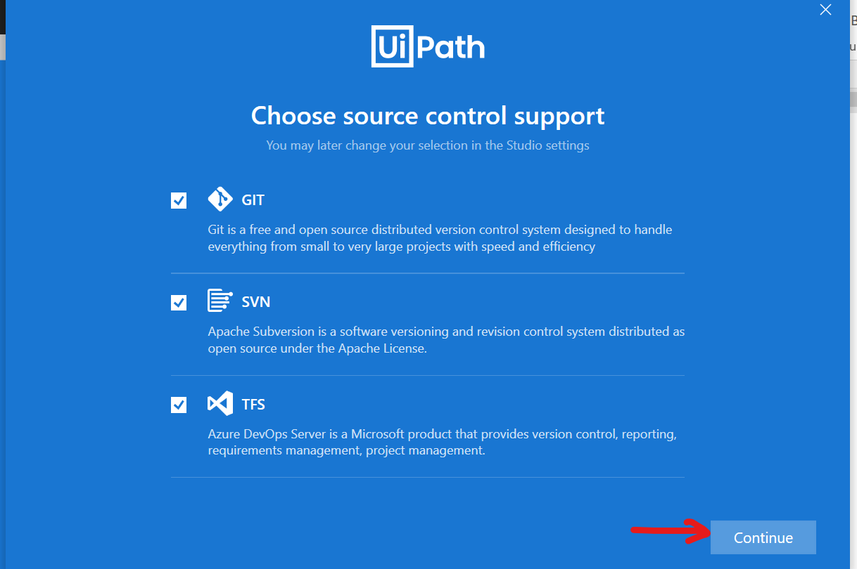

**\*Click on Continue.**

**\*Voila, UI path installed Sucessfully**

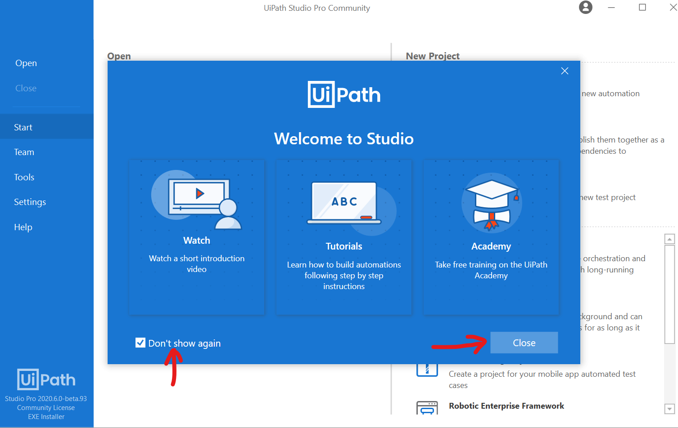

***\*After Installation go to the bot zip file extract the file according to the below steps then open the folder.***

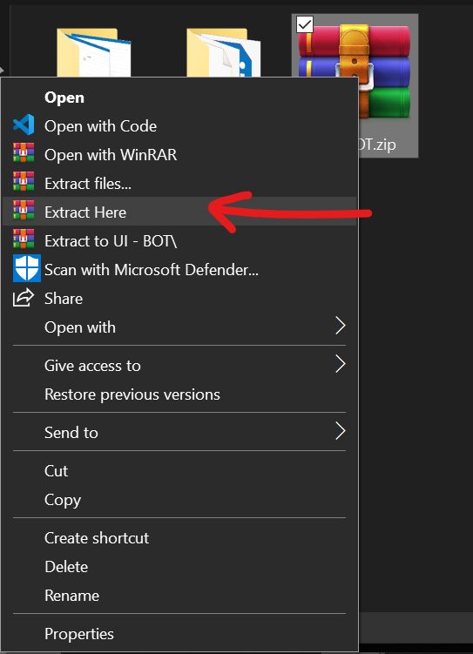

***\*Double click on the file with .xaml extension OR open it with UI Path***

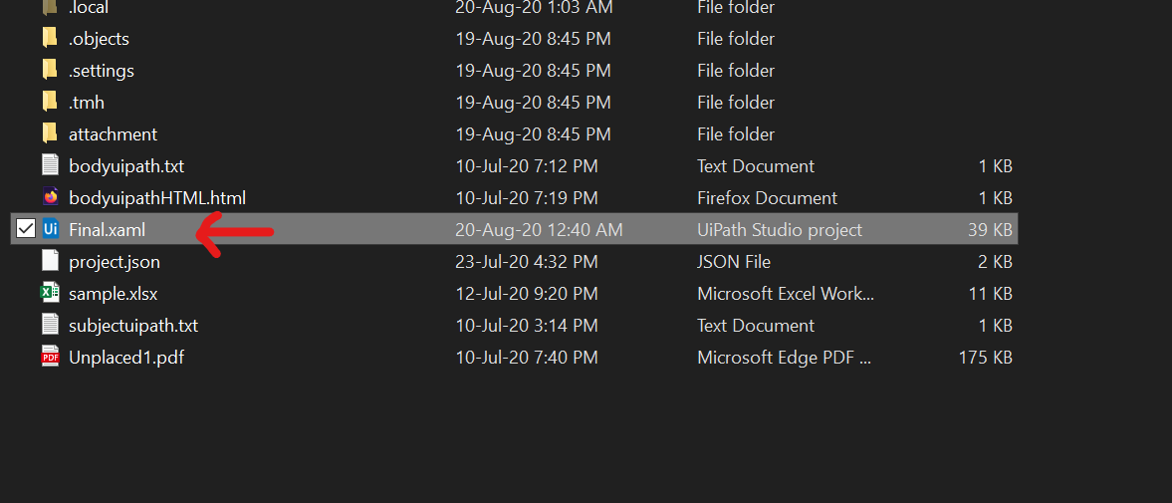

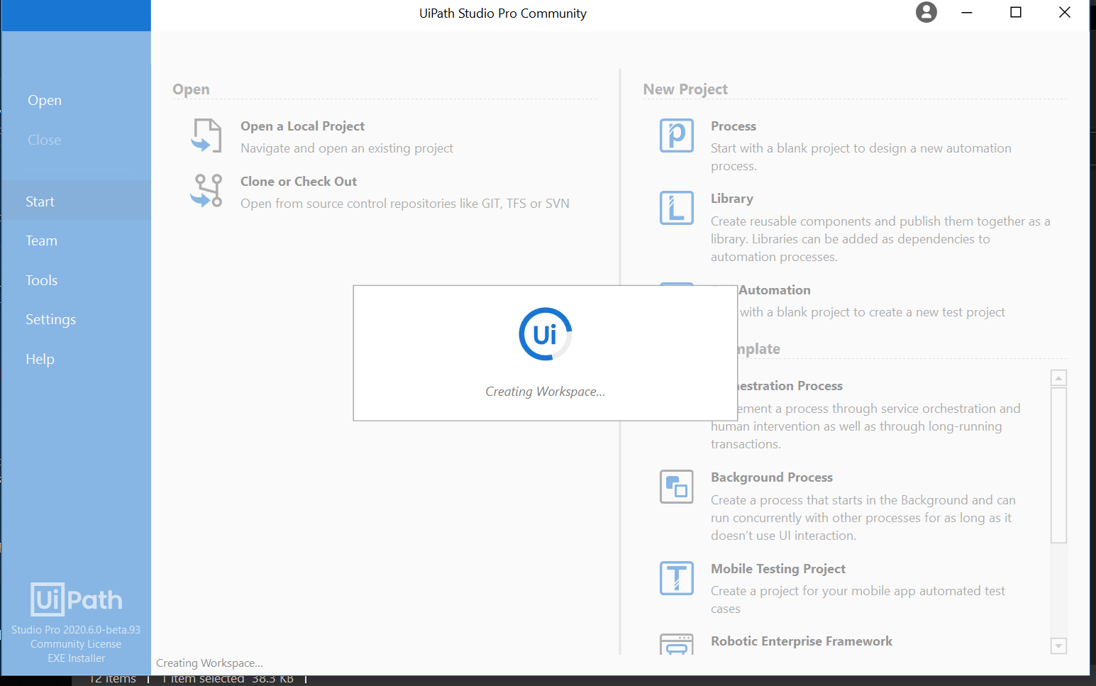

***\*It will take some time as it is downloading dependencies (this is a one time process keep the internet connected.)***

***\*After this is Bot file is open.***

***\*Now Scroll down and click for Send SMTP Mail Message you can change the below columns According to you,(the details you are filling are only the details from which name Mail Goes,***

***\*In From enter you Email, In Name Enter the name from which you want to send Mail)***

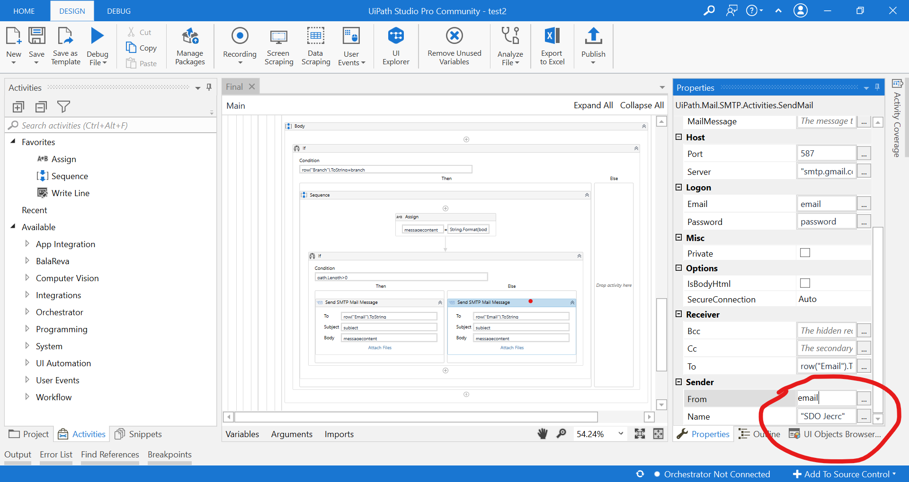

***\*[MUST]Before running the bot first enable the “Less Secure App Access”.***

***To do so follow the below steps***

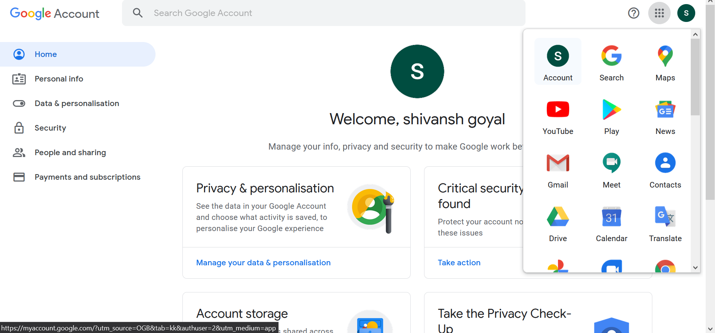

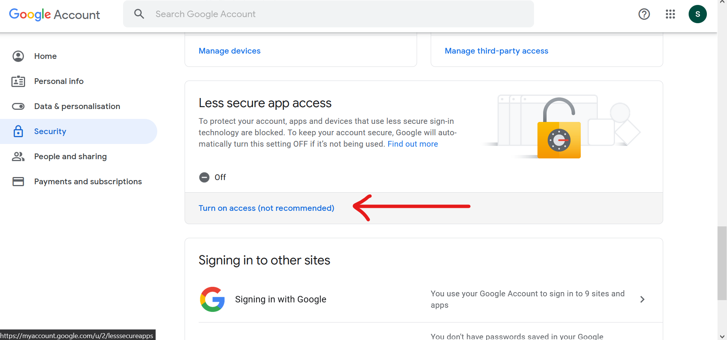

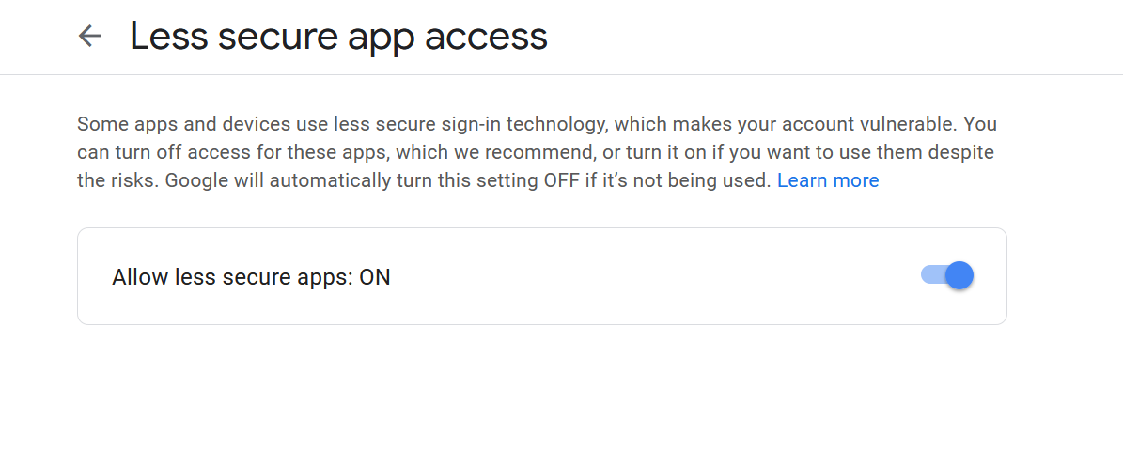

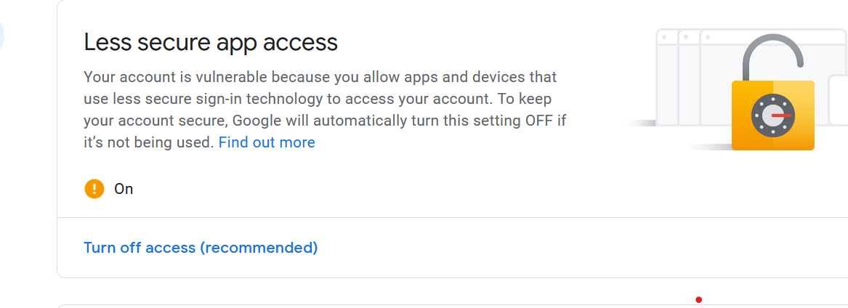

***\*Now we are ready to run the bot.***

***Follow the below Instructions.***

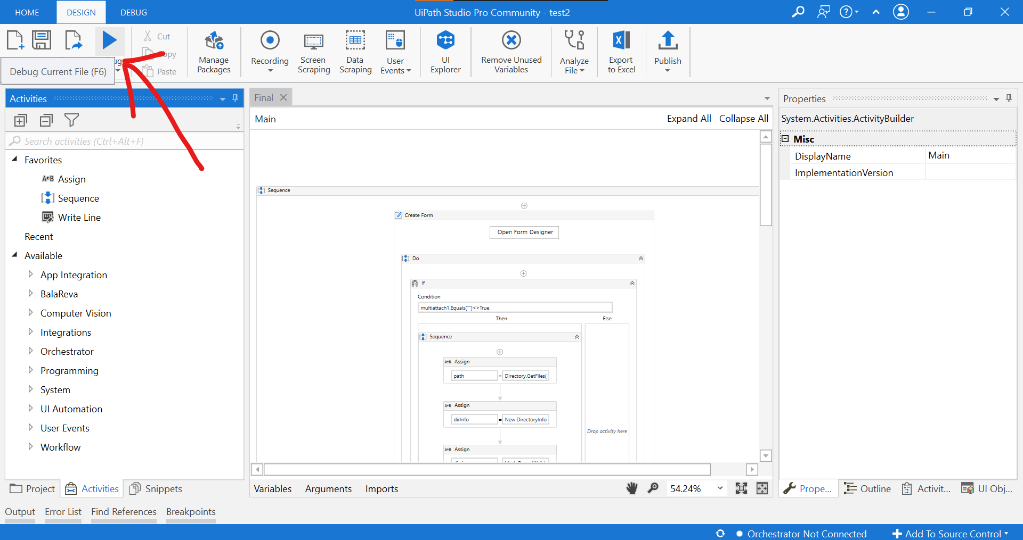

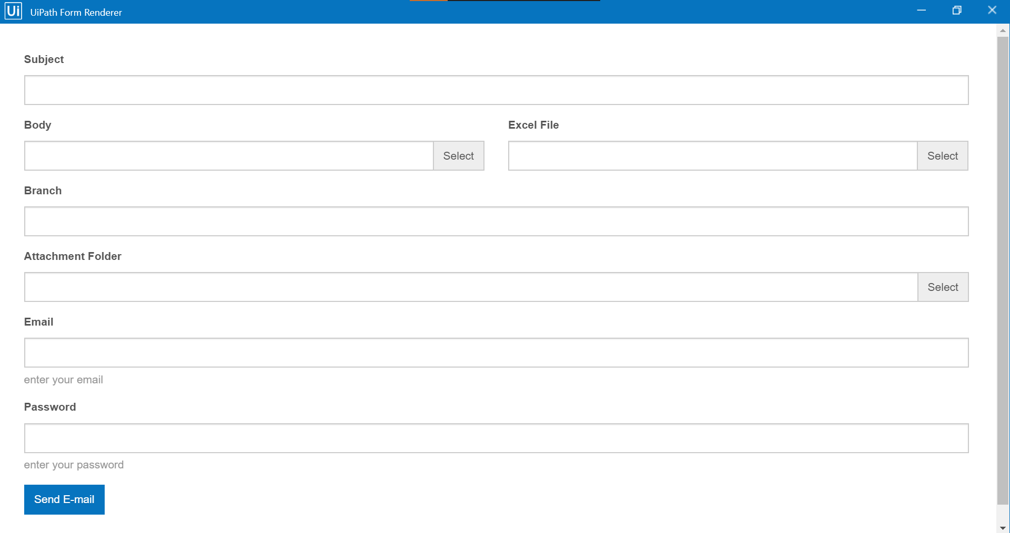

**\*Fill this form and upload the text file of body and the excel file.**

**In branch enter the branch you want to send email. You can create new text file for body or can edit the files which is already in that folder as per your convenience. In that file you have to write the body of the mail which you want to send.**

**\*Similarly In attachment folder if you want to send any attachment with your mail you have to keep that attachment in a particular folder then select that folder OR you can also leave it empty.**

**\*In the same manner you can select the body file (please refer to the pictures below)**

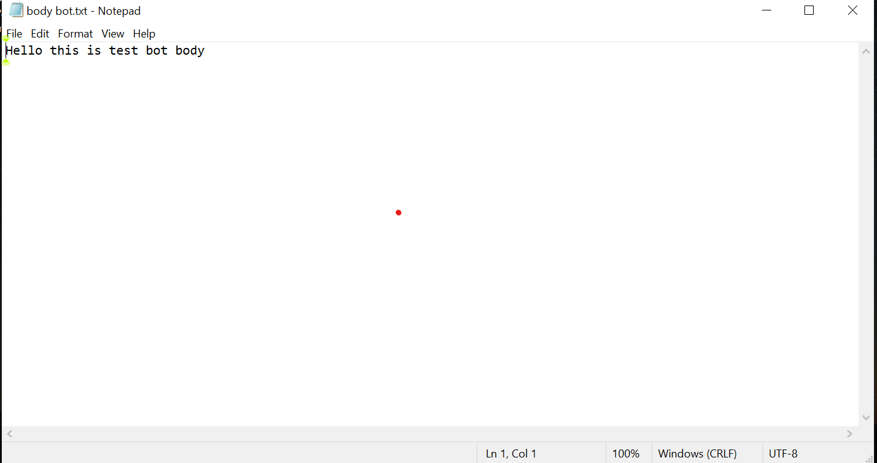

**\*You can select any text file you want to send as body in the mail.**

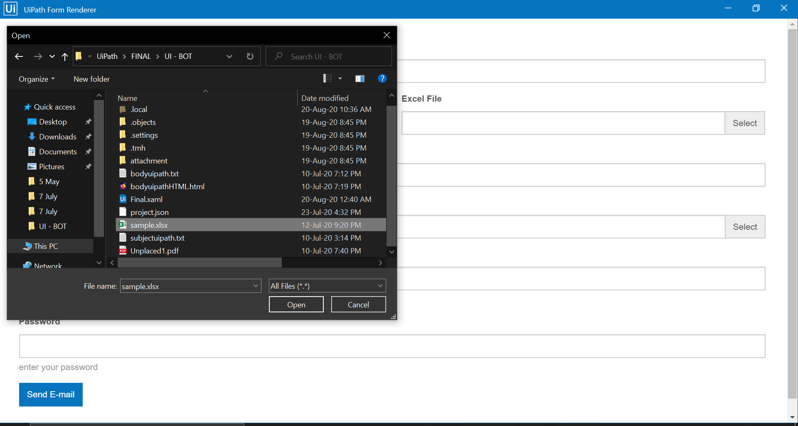

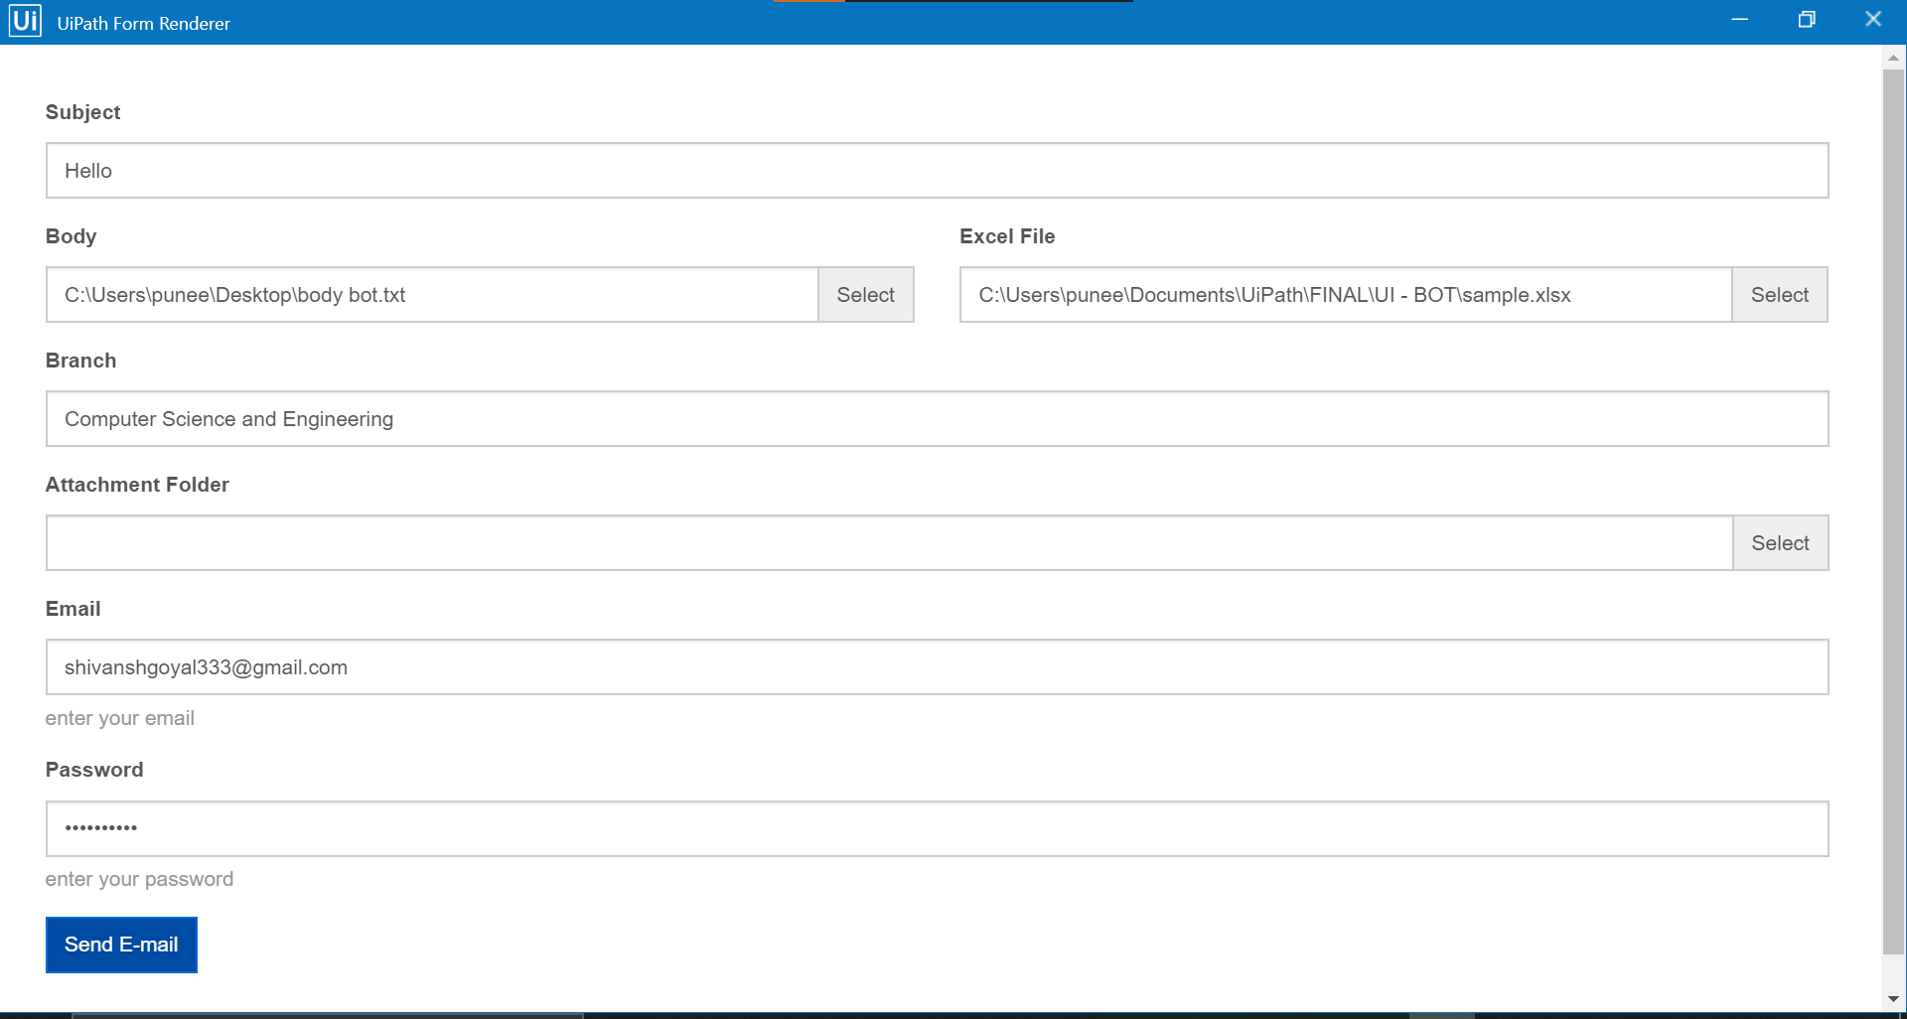

***\*Type your email/password from which you want to send mails.***

***After filling click Send E-mail button.***

***It will take few minutes to execute meanwhile don’t close the application it will automatically open the excel file you have selected during execution.***

***[Before starting bot please note that the excel file you want to select is closed .]***

Voila….You are now ready to rock!

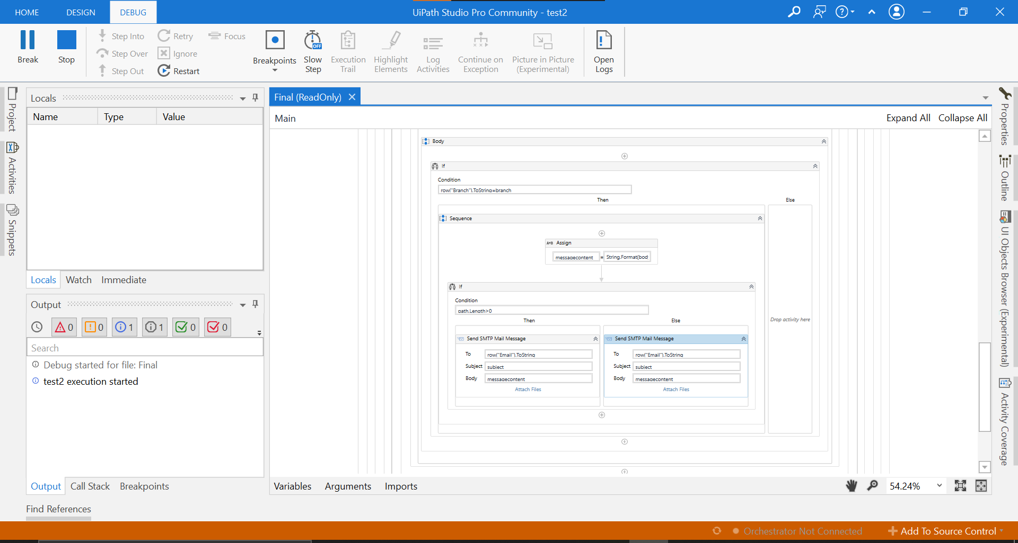*Open your gmail account and check sent/inbox option.

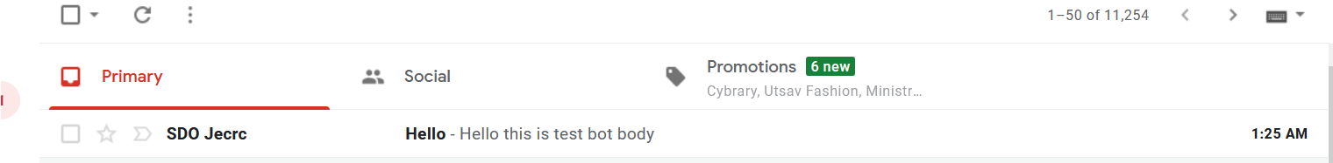

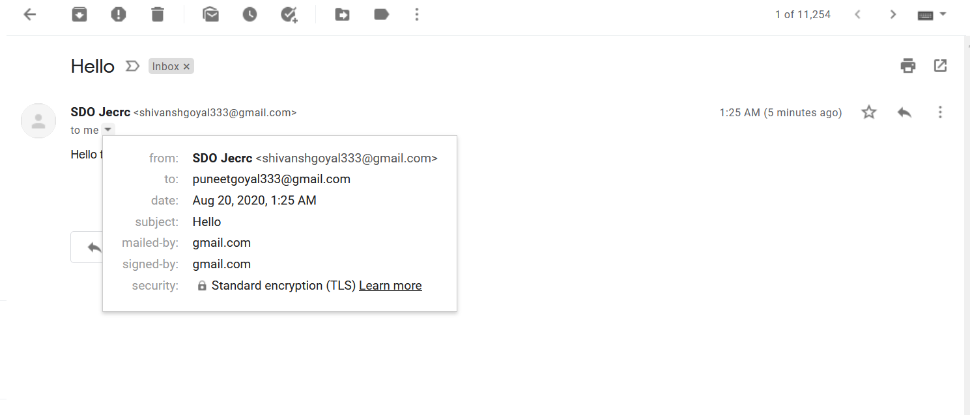

MAIL received.